VirtualBox Troubleshooting

May 22, 2020

Download Virtualbox <https://www.virtualbox.org/>

Install it

Attach appliance file you have been supplied

Start the image

# If you receive errors similar to these:

 VMMR0_DO_NEM_INIT_VM failed: VERR_NEM_MISSING_KERNEL_API_2 (VERR_NEM_MISSING_KERNEL_API_2).

VT-x is not available (VERR_VMX_NO_VMX).

|  |  |
| --- | --- |
| Result Code: | E_FAIL (0x80004005) |
| Component: | ConsoleWrap |
| Interface: | IConsole {872da645-4a9b-1727-bee2-5585105b9eed} |
|  |  |

# You may need to look at the following steps to resolve:

This could be the issue:

From some quick checking, it looks like this is a fairly new error that’s popping up for people and the suggested approach is to uninstall VirtualBox, remove any residual files, and reinstall.  Sorry, I don’t know more than that that I found on google:

<https://stackoverflow.com/questions/61344675/virtual-box-vt-x-is-not-available-verr-vmx-no-vmx-hyper-v-and-core-isolation>

## Check your Bios

1. Confirm that VT-x or VT-d are enabled.
2. Confirm that Intel Virtualization is enabled, if you see the option.

## Configure Windows 10

These settings work for me:

Note that disabling Hyper-V and Virtual Machine platform will break Docker.

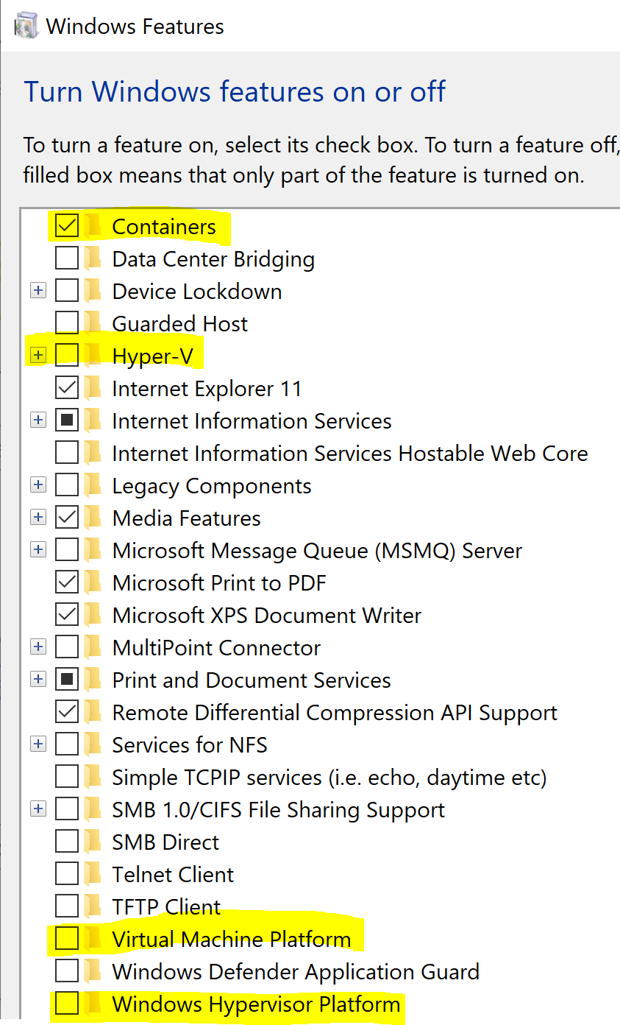

## Reinstall Virtual Box

1. Uninstall Virtual Box

It is listed in programs as Oracle VirtualBox

It is normally installed in folder C:\Program Files\Oracle\VirtualBox

1. Delete extra folders after uninstalling

* C:\Users\[username]\.VirtualBox
* C:\Users\[username]\VirtualBox VMs

1. You may also want to delete the .ova file that you imported, in case it could be corrupt.
2. Reboot
3. Reinstall VirtualBox and try to attach the image file, and start it.

## If it still fails after trying the above steps:

1. Go back into your bios
2. Disable the virtualization settings then re-enable them. Then save your settings and exit.